**AUTOMATE CLEAN**

**Large-Scale Dust Cleaning Robot**

**A MINI-PROJECT REPORT**

*Submitted by*

**SREENA R 2116210701256**

**SANGATHTAMIL S 2116210701228**

**SABARI MANI S 2116210701218**

***In partial fulfillment of the award of the degree***

***of***

**BACHELOR OF ENGINEERING**

**IN**

**COMPUTER SCIENCE AND ENGINEERING**



**RAJALAKSHMI ENGINEERING COLLEGE**

**AUTONOMOUS, CHENNAI**

**MAY 2024**

# **RAJALAKSHMI ENGINEERING COLLEGE, CHENNAI**

**BONAFIDE CERTIFICATE**

Certified that this Thesis titled **“AUTOMATE CLEAN-LARGE SCALE DUST CLEANING ROBOT**” is the bonafide work of “**SREENA R (2116210701256), SANGATHTAMIL S (2116210701228), SABARI MANI S (2116210701218)”** who carried out the work under my supervision.

Mr. K. Vijay B.Tech., M.E.,

**SUPERVISOR**

Assistant Professor (SG)

Department of Computer Science and Engineering

Rajalakshmi Engineering College

Chennai- 602 105

Submitted to Project Viva-Voce Examination held on ________________

**Internal Examiner External Examine**

**ABSTRACT**

The project “Automate Clean”, a large-scale dust cleaning through the integration of robotic technology. Traditional methods of cleaning expansive areas often suffer from inefficiencies, labor intensiveness, and limited coverage.The goal of designing a dust cleaning robot using embedded systems is to clean the floor automatically using a robot that can work in hazardous environments without the assistance of people, to construct a floor cleaning robot without a driver, and to develop an autonomous robotics system that uses the internet of things. It is typically used when large areas need to be cleaned with few obstructions. Most problems occur on huge floors beyond human capabilities. That means people can get exhausted over large areas of ground. The harmful radiations, chemicals, air pollution, and other factors might cause a man to become ill or perhaps die at places like nuclear facilities or chemical industries. Therefore, this robot can be used there to efficiently navigate and cleans large surface areas with unparalleled precision and effectiveness.

# **ACKNOWLEDGMENT**

First, we thank the almighty god for the successful completion of the project. Our sincere thanks to our chairman **Mr. S. Meganathan B.E., F.I.E.,** for his sincere endeavor in educating us in his premier institution. We would like to express our deep gratitude to our beloved Chairperson **Dr. Thangam Meganathan Ph.D.,** for her enthusiastic motivation which inspired us a lot in completing this project and Vice Chairman **Mr. Abhay Shankar Meganathan B.E., M.S.,** for providing us with the requisite infrastructure.

We also express our sincere gratitude to our college Principal,

**Dr. S. N. Murugesan M.E., PhD.,** and **Dr. P. KUMAR M.E., PhD, Director computing and information science , and Head Of Department of Computer Science and Engineering** and our project coordinator **Dr. K.Vijay M.E.,** for her encouragement and guiding us throughout the project towards successful completion of this project and to our parents, friends, all faculty members and supporting staffs for their direct and indirect involvement in successful completion of the project for their encouragement and support.

## **SREENA R**

## **SANGATHTAMIL S**

## **SABARI MANI S**

**TABLE OF CONTENTS**

| **CHAPTER NO** | **TITLE** | **PAGE NO** |
| --- | --- | --- |
|  | **ABSTRACT** | iii |
|  | **LIST OF FIGURES** | vi |
|  | **LIST OF TABLES** | vii |
| **1.** | **INTRODUCTION** | 1 |
|  | 1.1 RESEARCH PROBLEM | 2 |
|  | 1.2 PROBLEM STATEMENT | 2 |
|  | 1.3 SCOPE OF THE WORK | 2 |
|  | 1.4 AIM AND OBJECTIVES | 3 |
|  | 1.5 RESOURCES | 3 |
| **2.** | **LITERATURE SURVEY** | 4 |
| **3.** | **EXISTING SYSTEM** | 7 |
|  | 3.1 MANUAL CLEANING | 7 |
|  | 3.2 SEMI-AUTOMATIC CLEANING | 7 |
|  | 3.3 MECHANICAL FLOOR CLEANERS | 8 |
|  | 3.4 INDEPENDENT ROBOTS | 8 |
| **4.** | **PROPOSED SYSTEM** | 10 |
| **5.** | **SYSTEM DESIGN** | 11 |
|  | 5.1 SYSTEM SPECIFICATION | 11 |
|  | 5.1.1 HARDWARE SPECIFICATIONS | 11 |
|  | 5.1.2 SOFTWARE SPECIFICATIONS | 12 |
|  | 5.2 SYSTEM ARCHITECTURE | 13 |
|  | 5.3 SYSTEM METHODOLOGY | 13 |
| **6.** | **MODULE DESCRIPTION** | 16 |
| **7.** | **RESULTS AND DISCUSSIONS** | 24 |
|  | 7.1 SOURCE CODE | 24 |
|  | 7.2 OUTPUT | 29 |
|  | 7.3 RESULT | 32 |
| **8.** | **CONCLUSION AND FUTURE ENHANCEMENT** | 33 |
|  | **REFERENCES** | 35 |

**LIST OF FIGURES**

| **FIGURE NO** | **TITLE** | **PAGE NO** |
| --- | --- | --- |
| 5.1 | ARCHITECTURE DIAGRAM | 13 |
| 6.1 | ESP32 MICROCONTROLLER | 16 |
| 6.2 | L298N MOTOR DRIVER | 17 |
| 6.3 | PWM SPEED CONTROLLER | 18 |
| 6.4 | DC-DC BUCK CONVERTER | 18 |
| 6.5 | SERVO TESTER | 19 |
| 6.6 | DC BO Motor | 20 |
| 6.7 | BLDC Motor | 21 |
| 6.8 | ULTRASONIC SENSOR | 22 |
| 6.9 | IR SENSOR | 22 |
| 6.10 | LI-PO BATTERY | 23 |
| 7.1 | AUTOMATIC MODE | 29 |
| 7.2 | MANUAL MODE | 30 |
| 7.3 | DUST CLEANING ROBOT | 31 |

**LIST OF TABLES**

| **TABLE NO** | **TITLE** | **PAGE NO** |
| --- | --- | --- |
| 5.1 | HARDWARE SPECIFICATIONS | 11 |
| 5.2 | SOFTWARE SPECIFICATIONS | 12 |

**CHAPTER 1**

**INTRODUCTION**

In the pursuit of sustainable and efficient solutions for maintaining cleanliness in various environments, the convergence of green technology with upgrading in robotics has led to the development of innovative keys such as the "Automate Clean" project. This project represents a considerable leap forward in the realm of dust cleaning by applying the power of robotic technology integrated with embedded systems.

Green technology, often comparable with eco-friendly or sustainable technology, focuses on reducing environmental impact while enlarging the efficiency and effectiveness. It encloses a wide range of practices and innovations aimed at reducing resource consumption, pollution, and waste generation. The integration of green technology concepts into dust cleaning processes aligns with the global essentials to mitigate the environmental footprint of human activities.

Traditional methods of cleaning expansive areas have long been plagued by inefficiencies, labor intensiveness, and limited coverage. These shortcomings not only obstruct productivity but also pose risks to human health and safety, particularly in hazardous environments such as nuclear facilities or chemical industries. The "Automate Clean" project addresses these challenges head-on by leveraging robotic technology to automate floor cleaning operations.

At the core of the project is the design and development of a dust cleaning robot integrated with embedded systems. This robot is engineered to operate autonomously, navigating and cleaning large surface areas without the need for human intervention. By removing the reliance on human labor, the robot enhances safety by reducing human exposure to harmful radiations, chemicals, and air pollution prevalent in hazardous environments.

**1.1. RESEARCH PROBLEM**

The primary research problem addressed by the "Automate Clean" project is the inefficiency and safety hazards associated with traditional methods of cleaning large and hazardous areas. Current cleaning practices in expansive and dangerous environments are labor-intensive, time-consuming, and pose significant health risks to human workers. There is a pressing need for a solution that can improve the efficiency, effectiveness, and safety of these cleaning operations.

**1.2. PROBLEM STATEMENT**

The problem statement for the "Automate Clean" project is to develop an autonomous robotic cleaning system that integrates green technology and IoT capabilities to efficiently and safely clean large surface areas, particularly in hazardous environments. This system aims to reduce human labor, minimize environmental impact, and enhance operational efficiency through advanced robotic and digital technologies.

**1.3. SCOPE OF THE WORK**

The scope of the work includes the design, development, and implementation of a dust cleaning robot integrated with embedded systems and IoT technology. The project will involve extensive testing and optimization of the robot's autonomous navigation and cleaning capabilities in various environments. Additionally, the scope covers the evaluation of the system's performance, safety, and environmental impact, ensuring that the robot meets the required standards for effective and sustainable surface cleaning.

**1.4. AIM AND OBJECTIVES**

The aim of the "Automate Clean" project is to revolutionize surface cleaning operations through the development of an autonomous robotic cleaning system that leverages green technology and IoT. The objectives include:

* Designing and building a robotic cleaning system with embedded systems.
* Ensuring the robot can autonomously navigate and clean large areas.
* Integrating IoT for remote monitoring and control.
* Enhancing safety by minimizing human exposure to hazardous environments.
* Reducing environmental impact through efficient and sustainable cleaning practices.

**1.5. RESOURCES**

The resources required for the "Automate Clean" project include advanced robotic components, embedded systems, IoT modules, and sensors for autonomous navigation and cleaning. Additionally, software development tools for programming and testing the robot, access to various testing environments, and expertise in robotics, embedded systems, and IoT technology are essential. Collaboration with experts in green technology and sustainability will also be crucial to ensure the project's success.

**CHAPTER 2**

**LITERATURE SURVEY**

The structural framework of the propulsion control system of the surface robot is designed based on the principle of PWM speed control. AVR microprocessor and its software and hardware design proposals are presented. Through RS485 and PC communication according to the agreed protocol, the control system achieves robot forward, backward, turn and work operations by the use of a DC motor or stepper motor. [1]

The heart of the system is a microcontroller - Arduino. It is programmed to accept inputs to sense obstacles around it and control the robot to avoid any collisions. There are 4 IR sensors used in this project- one at the front, and the remaining on the left, right and back of the robot to detect obstacles. [2]

All hardware and software operations are controlled by AT89S52 microcontrollers. LM293D IC has been used to drive wheel motors. RF module has been used to transmit and receive the information between remote and robot and display the information related to the hurdle detection on LCD. The whole circuitry is connected with a 12V battery. [3]

The robot is fully autonomous and makes decisions on the basis of the outputs of infrared proximity sensors, ultrasonic sensors and tactile sensors after being processed by Arduino (mega) controller and control the actuators (2 DC encoder motors) by the H-bridge driving circuitry. In manual mode, the robot can also be used to clean a specific area of a room by controlling it manually from a laptop with a Graphical User Interface (GUI) via Bluetooth connectivity. [4]

The need of the project has come up because of a busy schedule of working people. Vacuum cleaner robot which has components DC motors, wheels, roller brush, cleaning mop, the garbage container and obstacle avoidance sensor & 12V rechargeable battery is used as power supply. [5]

The study was conducted using Pressman's research and development methods which included the following phases: analysis, design, implementation and testing.Floor cleaning performance on various types of dirt is quite good with only leaving dirt on the floor less than 20%. [6]

The most exceptional frameworks made by IROBOT and SCOOBA have utilized data from different sorts of sensors. The smoothness and versatility can depend on distinctive sensors for building the robot self-governing. [7]

The Radio Frequency is flow through surrounding us that is produced by the wireless communication such as GSM, 3G, 4G and so on to transfer data. Blynk provides a user-friendly platform for users to control devices and end up with output. [8]

The development of the robot starts with the design of a simple and most effective chassis for the robot which is a very important part as it has to carry all the weight on the robot. To run the bot, the sensors to be used, the microcontroller, the motor drivers, the wheels and other electronic components to be used on the robot. [9]

When the distance read by the ultrasonic sensor is below 15 cm. The results of testing the value of the ultrasonic sensor distance found different conditions that occur. In a distance of> 15 cm, the condition of the prototype cleaning robot for the road floor cleaning is obtained, while the distance <15 cm, the condition for the prototype of the street floor cleaning robot has stopped. [10]

This system consists of two vacuum compressors which are placed in front of the robot, for the operation of dry cleaning and a cleaning pad is placed behind the robot with water storage on it, which is supported for wet cleaning. Blynk app, Motor driver, Node MCU, Wi-Fi module.[11]

An autonomous floor cleaning robot that is dependent on ATMEGA IC has been created. Smartphone, ATmega328, Bluetooth module HC05, servomotor, motor driver IC LM293D, DC motor. This can be used for Low range Mobile Surveillance Devices. [12]

GSM module has been used for wireless communication between Robot and user.Main objective of this project is to design and implement a robot by using Arduino Mega, Ultrasonic Sensor, LCD display, etc. and thereby controlling the robot through user commands by means of GSM.[13]

Microcontroller Unit (MCU), Wireless Fidelity (Wi-Fi), Internet of Things (IOT), Graphical User Interface (GUI), Global System for Mobile Communication (GSM), Light Detection and Ranging(LIDAR), Ultrasonic sensor, Motor Driver IC, Arduino Nano, Node MCU, Blynk app, etc. [14]

The proposed robot is controlled by an Android mobile application or Blink which acts as a transmitter and gives commands to the receiver node MCU which has 11 I/O pins and 1 analogy pin. The Node MCU receives the instructions from the Wi-Fi receiver through the Android application, decodes the instructions, and guides the robot to the right path and direction.[15]

**CHAPTER 3**

**EXISTING SYSTEM**

**3.1. MANUAL CLEANING METHOD**

Traditional cleaning strategies for huge surfaces frequently depend on manual labor, which includes laborers utilizing apparatuses such as brooms, mops, and scrubbers. These strategies are time-consuming, and physically demanding. They moreover challenges in terms of productivity and consistency, particularly in dangerous environments.

* **Challenges:**

1. Labor Intensiveness: Manual cleaning requires significant human exertion, which can be debilitating and wasteful over expansive areas.
2. Inconsistency: Human cleaners can miss spots or give uneven cleaning quality.
3. Hazardous Situations: Cleaning in perilous zones such as atomic offices, chemical plants, and contaminated locales postures noteworthy wellbeing dangers to workers.

**3.2. SEMI-AUTOMATIC CLEANING METHOD**

These machines, such as ride-on floor scrubbers and sweepers, combine human operation with mechanized cleaning devices. They are more proficient than manual strategies and cover bigger zones with less physical effort.

* **Challenges:**

1. Operator Reliance: In spite of computerization, these machines still require human administrators, which does not completely dispense with labor costs and human fatigue.
2. Limited Independence: They need the capability to explore and clean independently, especially in complex or energetic environments.

**3.3. MECHANICAL FLOOR CLEANERS**

Robotic vacuum cleaners and floor scrubbers, such as the Roomba by iRobot and commercial floor scrubbers by companies like Tennant, offer more advanced computerization. These robots utilize sensors and straightforward route frameworks to clean floors with negligible human intervention.

* **Technologies:**

1. Basic Route: Numerous of these robots utilize pre-set designs or basic deterrent discovery to explore spaces.
2. Limited Customization: They are for the most part outlined for private or straightforward commercial situations and may battle in more complex or unsafe mechanical settings.

* **Challenges:**

1. Scalability: Whereas compelling in littler, obstacle-free situations, their execution can decay in bigger, more complex areas.
2. Hazard Taking care of: They are not planned to work in exceedingly unsafe situations where human security is a noteworthy concern.

**3.4. PROGRESSED INDEPENDENT ROBOTS**

Some progressed cleaning robots are planned for particular mechanical applications, highlighting more modern route frameworks, such as LiDAR and Hammer (Synchronous Localization and Mapping), to better get it and explore their environment.

* **Technologies:**

1. Advanced Sensors: Utilize LiDAR, cameras, ultrasonic sensors, and infrared sensors for exact route and impediment detection.
2. Autonomous Route: Calculations for way arranging and real-time alterations to maintain a strategic distance from deterrents and optimize cleaning routes.

* **Challenges:**

1. Cost: Progressed frameworks can be restrictively costly for broad adoption.
2. Complexity: Execution and upkeep require specialized information and aptitudes, possibly constraining their utilization in less mechanically progressed facilities.

**CHAPTER 4**

**PROPOSED SYSTEM**

The proposed system, "Automate Clean," builds on existing cleaning frameworks by independent navigation, IoT network, and upgraded security highlights to address the confinements of manual, semi-automatic, and fundamental mechanical cleaners. Conventional cleaning strategies depend intensely on manual labor, which is labor-intensive, conflicting, and dangerous in dangerous situations. Semi-automatic machines, whereas more proficient, still depend on human administrators and need full independence.

The Automate Clean framework joins state-of-the-art innovations such as the ESP32 microcontroller for central control, progressed engine drivers for exact development, and a combination of DC and BLDC engines to improve cleaning proficiency. It utilizes ultrasonic and IR sensors for exact impediment location and route, guaranteeing exhaustive cleaning indeed in complex situations. This permits the robot to adjust to different surfaces and impediments, giving a reliable and comprehensive cleaning execution over diverse environments.

An included highlight of the proposed framework is its IoT network, encouraged through the Blynk library and portable app. This integration permits for real-time checking, further control, and information examination, giving clients more prominent oversight and control over the cleaning operations.

**CHAPTER 5**

**SYSTEM DESIGN**

**5.1 SYSTEM SPECIFICATION**

**5.1.1 HARDWARE SPECIFICATIONS**

**Table 5.1 Hardware Specifications**

| **COMPONENTS** | **SPECIFICATIONS** |
| --- | --- |
| ESP32 MICROCONTROLLER | Dual-core, Wi-Fi, Bluetooth |
| L298N MOTOR DRIVER | 5-35V, 2A per channel, PWM control |
| PWM SPEED CONTROLLER | 6-30V, 5A, adjustablePWM |
| DC-DC BUCK CONVERTER | 4.5-28V input, 0.8-20V output, 3A |
| SERVO TESTER | 4.8-6V, manual/automatic modes |
| DC BO Motor | 3-12V, 150-300 RPM |
| BLDC Motor | 12V, 1000KV, low noise |
| ULTRASONIC SENSOR | 5V, 2- 400 cm range, ±3mm accuracy |
| IR SENSOR | 3.3-5V, 2-30cm range |
| LI-PO BATTERY | 11.1V, 2200mAh, 25C discharge rate |
| PROCESSOR | Intel Core i5 |
| RAM | 8 GB RAM |
| HARD DISK | 512 GB |
| PROCESSOR SPEED | Minimum 1.1 GHz |

**5.1.2 SOFTWARE SPECIFICATIONS**

**Table 5.2 Software Specifications**

| **COMPONENTS** | **SPECIFICATIONS** |
| --- | --- |
| Arduino IDE | Version 1.8.13, compatible with ESP32 |
| ESP32 Library for Arduino | Latest version, provides support for ESP32 |
| Blynk Library | Latest version, used for Blynk IoT integration |
| Mobile App | Blynk IoT, available on iOS and Android |

**5.2 SYSTEM ARCHITECTURE**

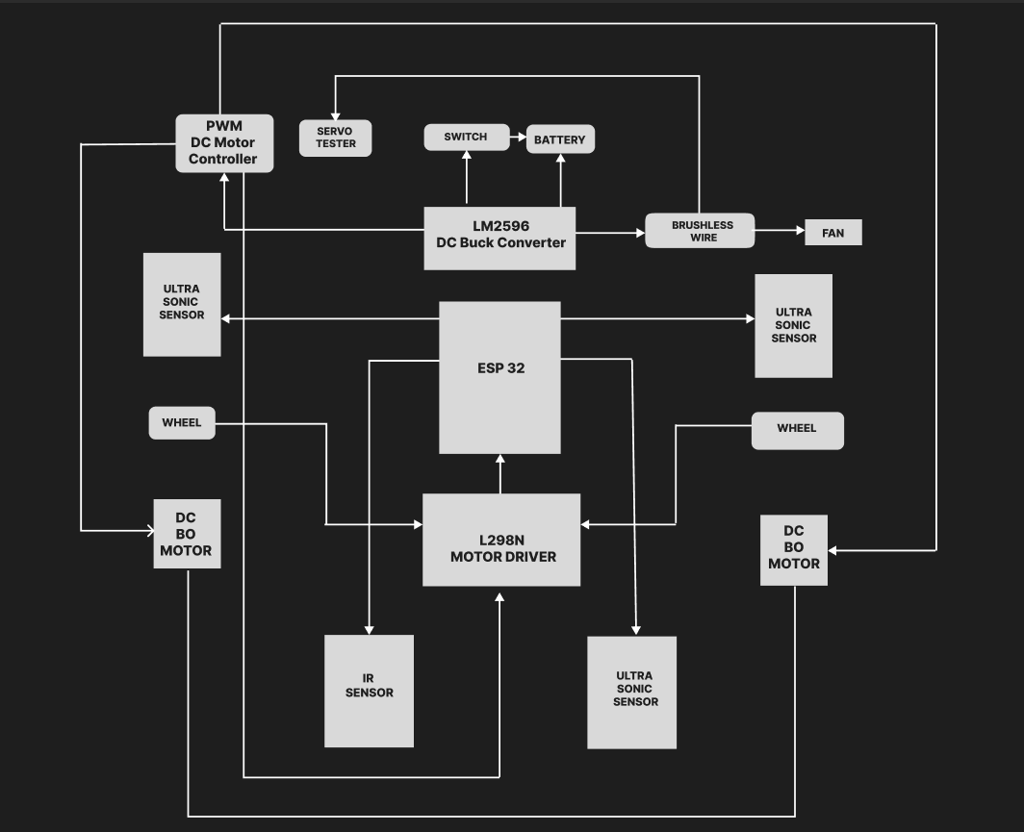

Fig 5.1 Architecture Diagram

**5.3 SYSTEM METHODOLOGY**

The proposed system for the "Automate Clean" robot involves the integration of several components, each playing a crucial role in the autonomous cleaning process. The core components include the ESP32 microcontroller, L298N motor driver, PWM speed controller, DC-DC buck converter, servo tester, ultrasonic sensor, IR sensor, and a Li-Po battery. Here's a detailed breakdown of how these components will work together:

**Integration**

1. **Power Supply:**
   1. The battery supplies power to the DC-DC buck converter, which then provides stable voltage to the ESP32, L298N motor driver, sensors, and other components.
2. **Motor Control:**
   1. The ESP32 sends PWM signals to the L298N motor driver via the PWM speed controller, controlling the speed and direction of the motors.
3. **Obstacle Detection:**
   1. Ultrasonic and IR sensors continuously monitor the surroundings for obstacles and edges.
   2. Sensor data is processed by the ESP32 to make real-time navigation decisions, avoiding obstacles and preventing falls.
4. **Cleaning Operation:**
   1. The robot follows a pre-programmed cleaning pattern or dynamically adjusts its path based on sensor input.
   2. It uses the ultrasonic and IR sensors to ensure thorough coverage of the area and avoid obstacles.
5. **IoT Integration:**
   1. The ESP32 connects to the internet, enabling remote monitoring and control.
   2. Users can start, stop, or schedule cleaning operations via a web interface or mobile app.
   3. The robot can send status updates, cleaning reports, and maintenance alerts.

**Flow of Operation**

1. **Initialization:**
   1. The robot powers on and initializes all components.
   2. Performs self-checks and calibrates sensors and motors.
2. **Navigation:**
   1. Begins cleaning following a predefined or dynamic path.
   2. Continuously scans for obstacles using ultrasonic and IR sensors.
   3. Adjusts movement to navigate around obstacles and ensure complete area coverage.
3. **Cleaning:**
   1. Activates cleaning mechanisms (e.g., brushes, suction) to clean the floor.
   2. Monitors cleaning progress and adjusts path as needed.
4. **Completion:**
   1. Once the area is cleaned or the battery is low, the robot returns to the charging station.
   2. Sends a completion report via the IoT interface.

**CHAPTER 6**

**MODULE DESCRIPTION**

1. **ESP32 Microcontroller**

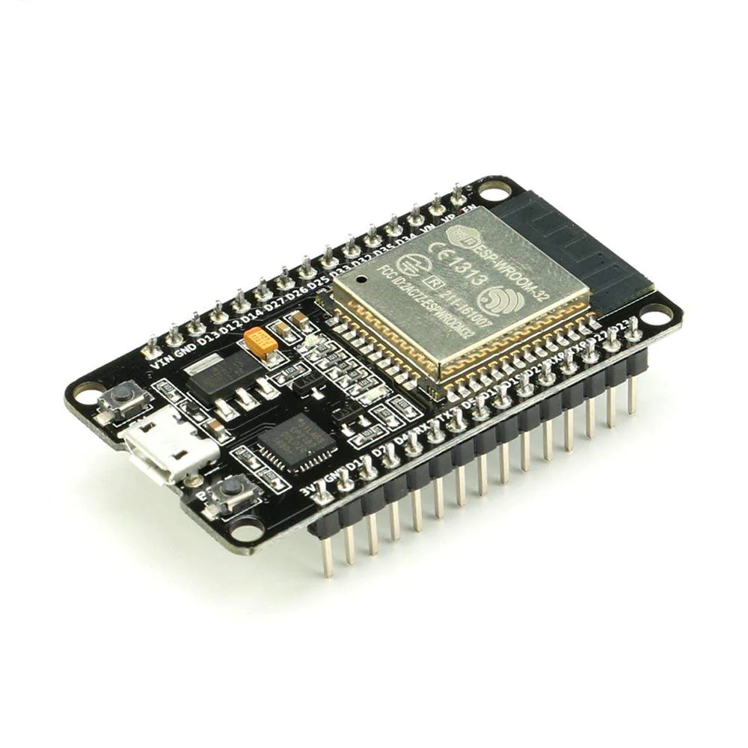

Fig 6.1 ESP32 Microcontroller

* 1. Role:
     1. Central processing unit (CPU) of the robot.
  2. Functions:
     1. Controls all other components.
     2. Processes data from sensors.
     3. Executes cleaning algorithms.
     4. Manages wireless communication for IoT functionalities

1. **L298N Motor Driver**

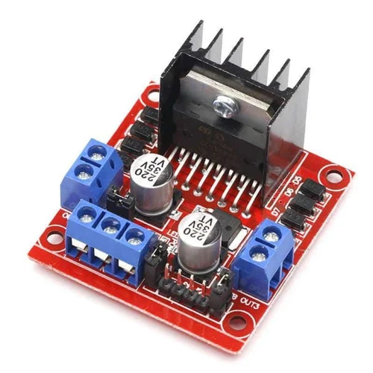

Fig 6.2 L298N Motor Driver

* 1. Role:
     1. Controls the DC motors that drive the robot.
  2. Functions:
     1. Provides bidirectional control for two DC motors.
     2. Manages the speed and direction of the motors based on PWM signals from the ESP32.
     3. Enables the robot to move forward, backward, and turn.

1. **PWM Speed Controller**

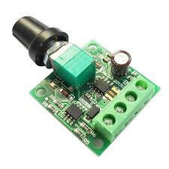

Fig 6.3 PWM Speed Controller

* 1. Role:
     1. Regulates the speed of the DC motors.
  2. Functions:
     1. Adjusts the duty cycle of PWM signals sent to the motor driver.
     2. Ensures smooth acceleration and deceleration of the robot.
     3. Provides precise speed control to navigate and clean effectively.

1. **DC-DC Buck Converter**

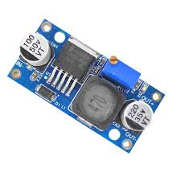

Fig 6.4 DC-DC Buck Converter

* 1. Role:
     1. Supplies a stable voltage to the components.
  2. Functions:
     1. Converts the higher voltage from the battery to the required lower voltage levels for the ESP32 and other components.
     2. Ensures that all electronic parts receive a consistent and appropriate power supply.

1. **Servo Tester**

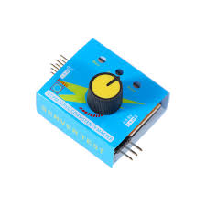

Fig 6.5 Servo Tester

* 1. Role:
     1. Manually tests and calibrates the servo motors.
  2. Functions:
     1. Allows for easy testing of servo motors without the need for a microcontroller.
     2. Used during the setup and debugging phases to ensure that servo motors operate correctly.

1. **DC BO Motor**

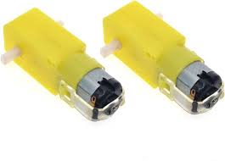

Fig 6.6 DC BO Motor

* 1. Role:
     1. The DC BO motor is responsible for the propulsion and movement of the robot, enabling it to navigate through the cleaning area.
  2. Function:
     1. Provides steady and reliable torque for driving the robot.
     2. Operates at low voltages, suitable for battery-powered applications.
     3. Offers a range of speeds (150-300 RPM)

1. **BLDC Motor**

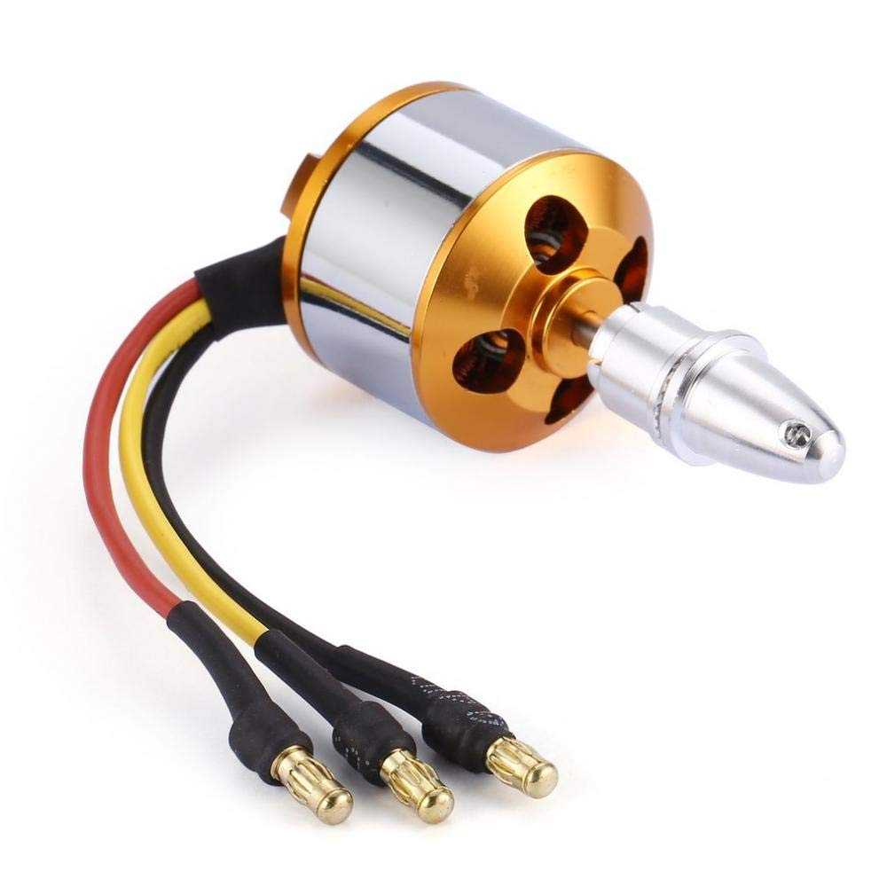

Fig 6.7 BLDC Motor

* 1. Role:
     1. The BLDC motor powers the cleaning brushes, ensuring efficient and thorough cleaning of surfaces.
  2. Function:
     1. High efficiency and low noise operation for a quieter cleaning experience.
     2. Operates at 12V with a high KV rating (1000KV) to achieve the necessary speed for deep cleaning.

1. **Ultrasonic Sensor**

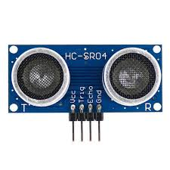

Fig 6.8 Ultrasonic Sensor

* 1. Role:
     1. Detects obstacles and measures distance.
  2. Functions:
     1. Provides distance measurements to the ESP32 for obstacle avoidance.
     2. Helps in mapping the environment and planning the cleaning path.

1. **IR Sensor**

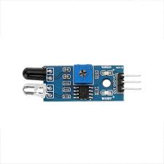

Fig 6.9 IR Sensor

* 1. Role:
     1. Detects edges and obstacles.
  2. Functions:
     1. Identifies the presence of objects or drop-offs (e.g., stairs, edges).
     2. Provides additional data to the ESP32 for navigation and safety.

1. **Li-Po Battery**

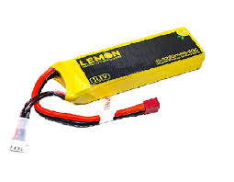

Fig 6.10 Li-Po Battery

* 1. Role:
     1. The Li-Po battery provides the necessary power for the robot, ensuring long operation times and stable performance.
  2. Function
     1. High energy density for extended run times.
     2. Lightweight and compact.
     3. Provides stable voltage output.

**CHAPTER 7**

**RESULTS AND DISCUSSIONS**

**7.1 SOURCE CODE**

#define BLYNK_PRINT Serial

#define BLYNK_TEMPLATE_ID "TMPL3Ig0vOgqV"

#define BLYNK_TEMPLATE_NAME "AutomateClean1"

#include <WiFi.h>

#include <WiFiClient.h>

#include <BlynkSimpleEsp32.h>

char auth[] = "NLNeSMceeDxDit9ZlhVwrJxqwQ3iU0tg"; // Replace with your Blynk Auth Token

char ssid[] = "Sreena"; // Replace with your WiFi SSID

char pass[] = "crayon305"; // Replace with your WiFi Password

// Define ultrasonic sensor pins

const int lftrigPin1 = 13;

const int lfechoPin1 = 12;

const int rgtrigPin2 = 27;

const int rgechoPin2 = 14;

const int mtrigPin3 = 26;

const int mechoPin3 = 25;

// Define IR sensor pin

const int irPin = 2;

// Define motor control pins

const int motor1A = 4; // Motor 1 control pin A

const int motor1B = 5; // Motor 1 control pin B

const int motor2A = 18; // Motor 2 control pin A

const int motor2B = 19; // Motor 2 control pin B

void setup() {

// Set ultrasonic sensor pins as input and IR sensor pin as input

pinMode(lftrigPin1, OUTPUT);

pinMode(lfechoPin1, INPUT);

pinMode(rgtrigPin2, OUTPUT);

pinMode(rgechoPin2, INPUT);

pinMode(mtrigPin3, OUTPUT);

pinMode(mechoPin3, INPUT);

pinMode(irPin, INPUT);

// Set motor control pins as outputs

pinMode(motor1A, OUTPUT);

pinMode(motor1B, OUTPUT);

pinMode(motor2A, OUTPUT);

pinMode(motor2B, OUTPUT);

// Initialize Serial communication for debug messages

Serial.begin(9600);

}

void loop() {

// Read sensor data

int distance1 = readDistance(lftrigPin1, lfechoPin1);

int distance2 = readDistance(rgtrigPin2, rgechoPin2);

int distance3 = readDistance(mtrigPin3, mechoPin3);

int irState = digitalRead(irPin);

// Print sensor readings for debug

Serial.print("Distance 1: ");

Serial.println(distance1);

Serial.print("Distance 2: ");

Serial.println(distance2);

Serial.print("Distance 3: ");

Serial.println(distance3);

Serial.print("IR State: ");

Serial.println(irState);

// Check sensor conditions and move accordingly

if (irState == HIGH || distance1 < 20 || distance2 < 20 || distance3 < 20) {

stopMotors();

delay(1000); // Stop for 1 second

if (irState == HIGH) {

reverse();

delay(2000); // Reverse for 2 seconds

} else if (distance1 < 20) {

turnRight();

delay(1000); // Turn right for 1 second

} else if (distance2 < 20) {

turnLeft();

delay(1000); // Turn left for 1 second

} else if (distance3 < 20) {

turnLeft();

delay(1000); // Turn left for 1 second

}

} else {

// No obstacle, move forward

moveForward();

}

}

// Function to read distance from ultrasonic sensor

int readDistance(int trigPin, int echoPin) {

digitalWrite(trigPin, LOW);

delayMicroseconds(2);

digitalWrite(trigPin, HIGH);

delayMicroseconds(10);

digitalWrite(trigPin, LOW);

long duration = pulseIn(echoPin, HIGH);

int distance = duration * 0.034 / 2; // Convert pulse duration to distance in cm

return distance;

}

// Function to move forward

void moveForward() {

digitalWrite(motor1A, LOW);

digitalWrite(motor1B, HIGH);

digitalWrite(motor2A, LOW);

digitalWrite(motor2B, HIGH);

}

// Function to reverse

void reverse() {

digitalWrite(motor1A, HIGH);

digitalWrite(motor1B, LOW);

digitalWrite(motor2A, HIGH);

digitalWrite(motor2B, LOW);

}

// Function to stop motors

void stopMotors() {

digitalWrite(motor1A, LOW);

digitalWrite(motor1B, LOW);

digitalWrite(motor2A, LOW);

digitalWrite(motor2B, LOW);

}

// Function to turn right

void turnRight() {

digitalWrite(motor1A, LOW);

digitalWrite(motor1B, HIGH);

digitalWrite(motor2A, HIGH);

digitalWrite(motor2B, LOW);

}

// Function to turn left

void turnLeft() {

digitalWrite(motor1A, HIGH);

digitalWrite(motor1B, LOW);

digitalWrite(motor2A, LOW);

digitalWrite(motor2B, HIGH);

}

**7.2 OUTPUT**

**INTEGRATION USING BLYNK**

**7.2.1 AUTOMATIC MODE**

The automatic mode triggered by a button press using Blynk, you can use a Blynk button widget to control the mode to on and off the robot.

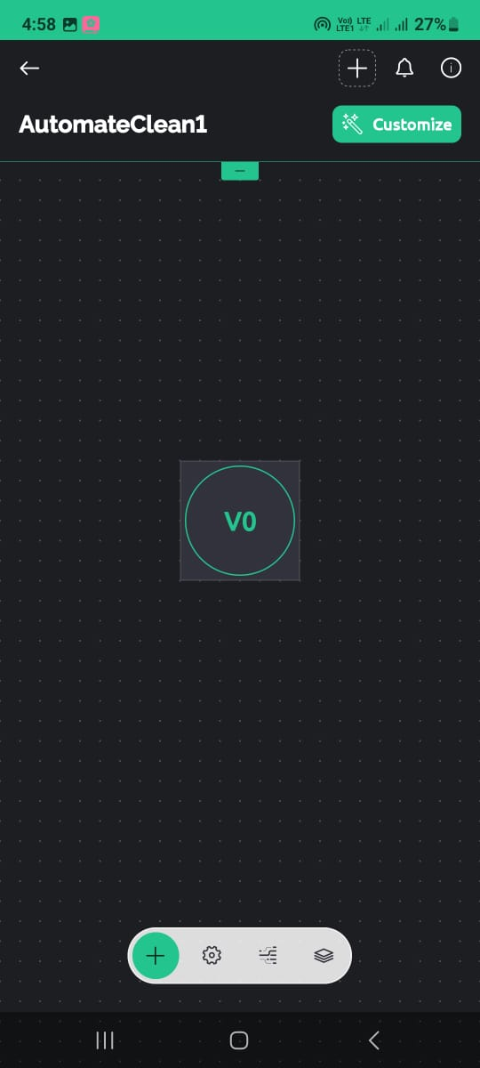

**Fig 7.1 AUTOMATIC MODE**

**7.2.2 MANUAL MODE**

The manual mode triggered by a button press using Blynk, you can use a Blynk button widget to control the mode to turn right, turn left, move forward, move backward.

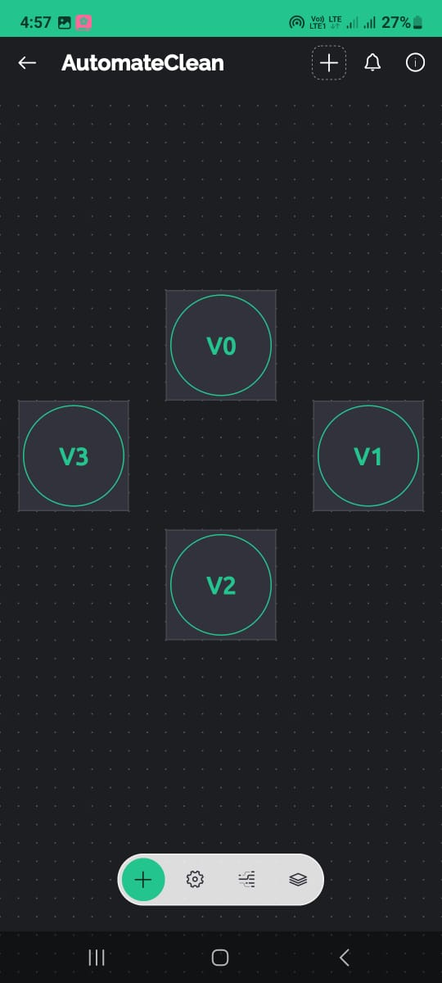

**Fig 7.2 MANUAL MODE**

**DUST CLEANING ROBOT**

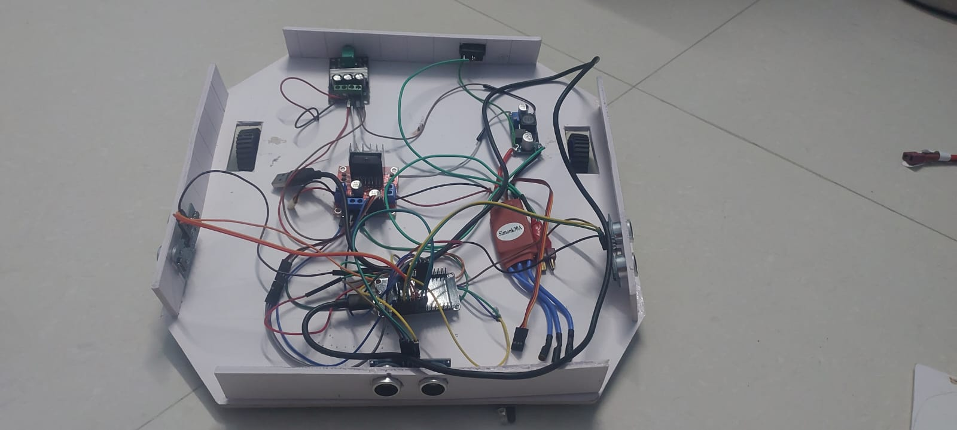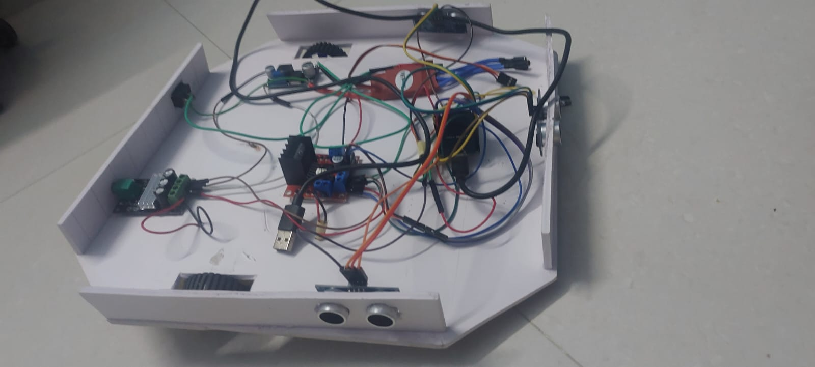

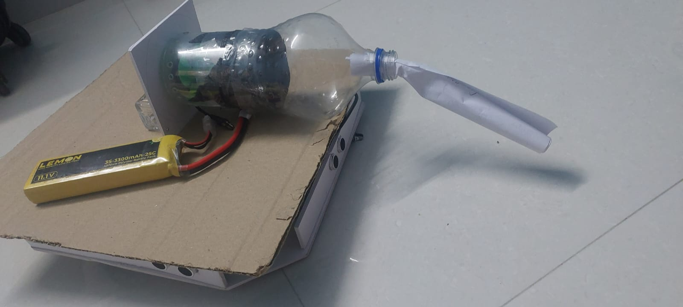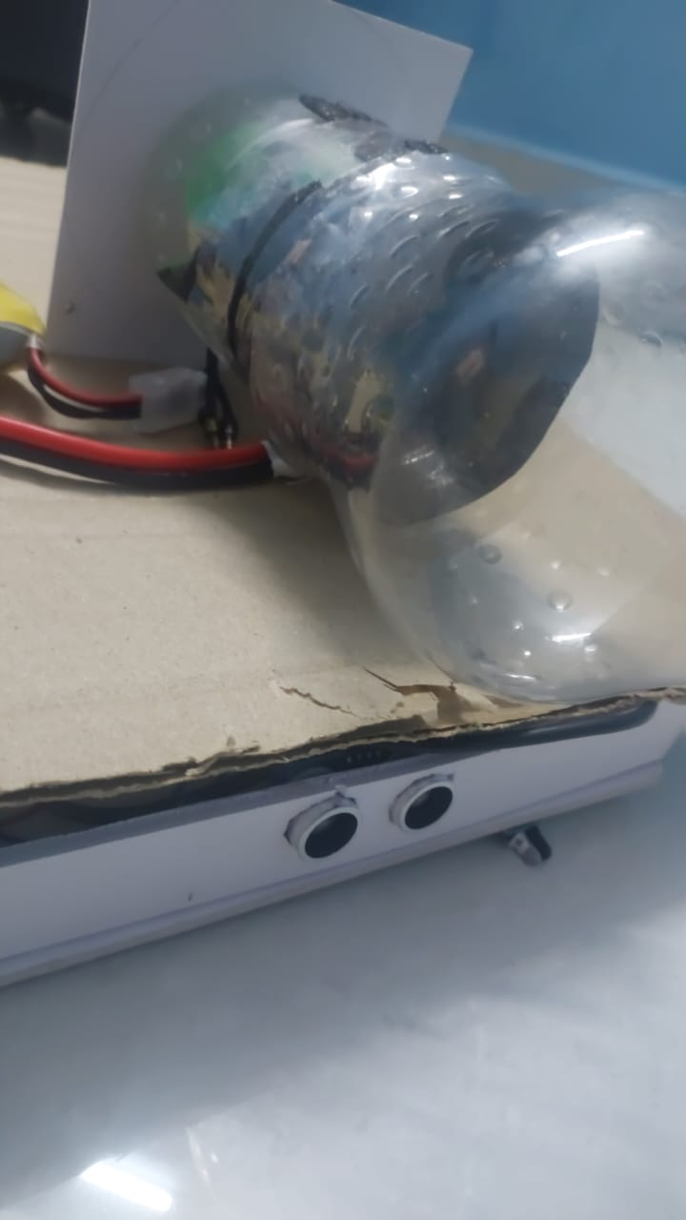

**Fig 7.3 Dust Cleaning Robot**

**7.3 RESULT**

The "Automate Clean" project integrated with Blynk, the robot offers dual operational modes: automatic and manual. In automatic mode, the robot navigates autonomously, utilizing sensor data to detect and avoid obstacles, ensuring thorough cleaning without human intervention. Meanwhile, manual mode enables remote control via the Blynk app, providing users with flexibility and convenience in directing the robot's movements

**CHAPTER 8**

**CONCLUSION AND FUTURE ENHANCEMENT**

**CONCLUSION**

"Automate Clean” represents a significant step forward in the field of autonomous cleaning solutions. By leveraging robotic technology and IoT integration, the project addresses critical inefficiencies and safety concerns associated with traditional cleaning methods. The autonomous dust cleaning robot developed under this project promises to deliver high precision and effectiveness, making it an invaluable tool in maintaining cleanliness in large and hazardous areas. As the project continues to evolve, it will further solidify its role in transforming industrial and public space maintenance, contributing to safer and more efficient operations across various sectors.

**FUTURE WORKS**

1. Real-Time Path Optimization: Develop algorithms for real-time path optimization to improve coverage efficiency and reduce cleaning time.
2. Voice and Gesture Control: Implement voice and gesture recognition technologies for more natural and intuitive human-robot interactions.
3. Enhanced Hazard Detection: LiDAR can detect minute particles and changes in the environment, providing advanced warnings of potential hazards such as spills or debris that need immediate cleaning.

**REFERENCES**

[1] Yuyi, Zhai, Zhou Yu, Luo Huanxin, Liu Yunjia, and Liu Liang. "Control system design for a surface cleaning robot." *International journal of advanced robotic systems* 10, no. 5 (2013): 220.

[2] Pandey, Abhishek, Anirudh Kaushik, Amit Kumar Jha, and Girish Kapse. "A technological survey on autonomous home cleaning robots." *International Journal of Scientific and Research Publications* 4, no. 4 (2014): 1-7.

[3] Kaur, Manreet, and Preeti Abrol. "Design and development of floor cleaner robot (automatic and manual)." *International Journal of Computer Applications* 97, no. 19 (2014).

[4] Khalid, Uman, Muhammad Faizan Baloch, Haseeb Haider, Muhammad Usman Sardar, Muhammad Faisal Khan, Abdul Basit Zia, and Tahseen Amin Khan Qasuria. "Smart floor cleaning robot (CLEAR)." (2015).

[5] Kukde, Manisha, Sanchita Nagpurkar, Akshay Dhakulkar, and Akshay Amdare. "Automatic & manual vacuum cleaning robot." International Research Journal of Engineering and Technology (IRJET) 5, no. 02 (2018): 2196-2198.

[6] Yatmono, S., M. Khairudin, H. S. Pramono, and A. Asmara. "Development of intelligent floor cleaning robot." In *Journal of Physics: Conference Series*, vol. 1413, no. 1, p. 012014. IOP Publishing, 2019.

[7] Parmar, Harshvardhansinh, Anilkumar Meena, Jafarali Bhovaniya, and Miteshkumar Priyadarshi. "Automatic smart mop for floor cleaning." *International Research Journal of Engineering and Technology (IRJET)* 6, no. 4 (2019): 3159-3165.

[8] Indra, Win Adiyansyah, and C. H. Yang. "Development of multi-controlled floor vacuum cleaner using RF energy harvesting." *ARPN Journal of Engineering and Applied Science* 14, no. 21 (2019): 3738-3742.

[9] Adithya, P. S., R. Tejas, V. Sai Varun, and B. N. Prashanth. "Design and development of automatic cleaning and mopping robot." In *IOP Conference Series: Materials Science and Engineering*, vol. 577, no. 1, p. 012126. IOP Publishing, 2019.

[10] Irawan, Yuda, Muhardi Muhardi, Rian Ordila, and Roni Diandra. "Automatic floor cleaning robot using arduino and ultrasonic sensor." *Journal of Robotics and Control (JRC)* 2, no. 4 (2021): 240-243.

[11] B. Sonia P.Ganesh.”Design and implementation of floor cleaning robot using Iot”. (2021)

[12] Kumbhar, Vijayalaxmi S., Dnyaneshwari Jagtap, Mansi Kulkarni, and Salim Lakade. "AUTONOMOUS FLOOR CLEANING ROBOT." (2021).

[13] Kore, Sharada L., Sonal M. Patil, Roshana J. Sapkal, Savita A. Itkarkar, and Roma R. Jain. "Floor Cleaning Smart Robot."

[14] Patil, Virta Banduji. "Design For Dust Cleaning Robot Using Embedded System." In *2023 3rd International Conference on Smart Data Intelligence (ICSMDI)*, pp. 579-583. IEEE, 2023

[15] Kachhela, Heena B., Ms Mamta Shyam Khadse, Sneha R. Bhange, Mr Tarun Prashant Ramteke, Ms Achal Ravindra Meshram, and Mr Manav Ravi Kamble. "DESIGN AND IMPLEMENTATION OF FLOOR CLEANING ROBOT USING IOT.".